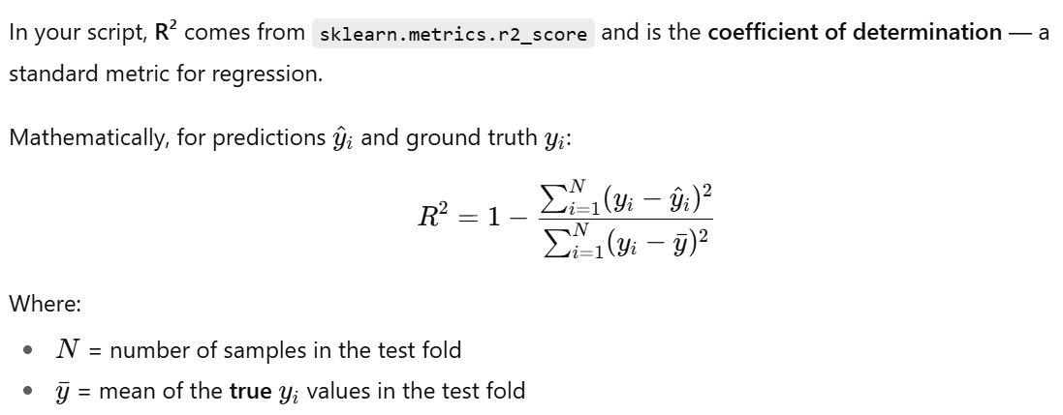

**Key points:**

* **R² = 1.0** → Perfect prediction.
* **R² = 0** → Model predicts no better than the mean of yyy.
* **R² < 0** → Model is worse than just predicting the mean; it overfits or fails to capture the relationship.
* Because you’re doing LOSO, negative R² in some folds is common when between-subject variability is large.

Target: Y_DAN

Loaded X_band: (49026, 31, 5, 5), 22 subjects

Fold 01 R2: 0.140

Fold 02 R2: 0.063

Fold 03 R2: 0.037

Fold 04 R2: 0.032

Fold 05 R2: 0.055

Fold 06 R2: 0.067

Fold 07 R2: 0.014

Fold 08 R2: 0.137

Fold 09 R2: 0.013

Fold 10 R2: 0.027

Fold 11 R2: 0.110

Fold 12 R2: 0.172

Fold 13 R2: 0.048

Fold 14 R2: 0.047

Fold 15 R2: 0.008

Fold 16 R2: 0.028

Fold 17 R2: -0.009

Fold 18 R2: 0.136

Fold 19 R2: 0.145

Fold 20 R2: 0.084

Fold 21 R2: 0.029

Fold 22 R2: 0.134

Overall LOSO R^2: 0.070

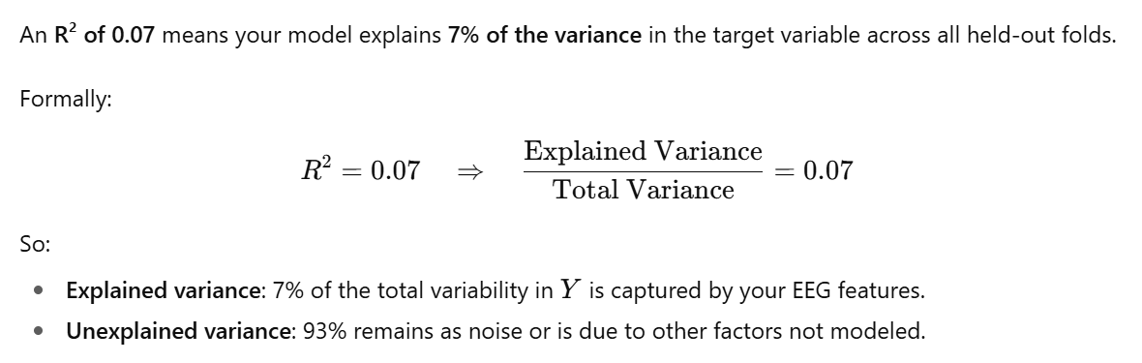

Top features by XGBoost gain:

1. ch09|Alpha|t=-2.5s gain=1.509e+05

2. ch07|Alpha|t=-2.5s gain=1.177e+05

3. ch06|Alpha|t=-2.5s gain=8.441e+04

4. ch08|Alpha|t=-2.5s gain=5.343e+04

5. ch09|Beta|t=-2.5s gain=4.038e+04

6. ch09|Alpha|t=-0.5s gain=3.645e+04

7. ch09|Alpha|t=-4.5s gain=3.158e+04

8. ch18|Alpha|t=-0.5s gain=3.129e+04

9. ch16|Gamma|t=-0.5s gain=3.111e+04

10. ch00|Delta|t=-4.5s gain=3.102e+04

11. ch19|Gamma|t=-0.5s gain=2.977e+04

12. ch07|Alpha|t=-0.5s gain=2.896e+04

13. ch07|Alpha|t=-4.5s gain=2.776e+04

14. ch06|Alpha|t=-0.5s gain=2.752e+04

15. ch03|Gamma|t=-0.5s gain=2.728e+04

16. ch07|Theta|t=-8.5s gain=2.475e+04

17. ch07|Beta|t=-2.5s gain=2.468e+04

18. ch01|Delta|t=-4.5s gain=2.419e+04

19. ch18|Beta|t=-2.5s gain=2.391e+04

20. ch08|Alpha|t=-4.5s gain=2.384e+04

21. ch20|Theta|t=-6.5s gain=2.265e+04

22. ch18|Alpha|t=-2.5s gain=2.264e+04

23. ch16|Gamma|t=-2.5s gain=2.215e+04

24. ch30|Alpha|t=-0.5s gain=2.2e+04

25. ch01|Gamma|t=-0.5s gain=2.198e+04

Band x Time (sum gain over channels):

Delta: -0.5s:2.28e+05, -2.5s:2.69e+05, -4.5s:2.7e+05, -6.5s:2.14e+05, -8.5s:2.31e+05

Theta: -0.5s:2.32e+05, -2.5s:2.2e+05, -4.5s:2.33e+05, -6.5s:2.52e+05, -8.5s:2.84e+05

Alpha: -0.5s:3.82e+05, -2.5s:6.84e+05, -4.5s:3.1e+05, -6.5s:2.84e+05, -8.5s:3.04e+05

Beta: -0.5s:2.25e+05, -2.5s:3.27e+05, -4.5s:2.81e+05, -6.5s:1.83e+05, -8.5s:2.1e+05

Gamma: -0.5s:3.4e+05, -2.5s:3.25e+05, -4.5s:2.25e+05, -6.5s:2.77e+05, -8.5s:2.63e+05